# Google Analytics 4 implementation plan guide

## Project scenario

As a digital marketing analyst, you’re in charge of the Google Analytics 4 implementation plan by setting up the account that is linked to the company’s website, configuring tracking, and generating insights to optimize website performance to achieve business objectives. Friska is planning to launch a new line of deodorants targeted at active individuals. As part of the marketing strategy, your objective is to create a Google Analytics 4 implementation plan to track the performance of the company's website and measure the effectiveness of the marketing campaigns for the new deodorant line.

**Note**: This guide walks you through a checklist of steps to complete in order to apply a Google Analytics 4 implementation plan for Friska’s website.

## Step-by-Step Instructions

### Step 1: Define objectives and goals of the implementation plan.

The first step in a Google Analytics 4 implementation plan is to define the goals of the plan. Friska’s website, [www.friskadeodorant.com](http://www.friskadeodorant.com), serves as the primary online platform for showcasing the new deodorant products and engaging with potential customers. Friska’s marketing SMART objectives for the implementation plan are to:

* Increase website traffic by 20% in the next 6 months.
* Boost online conversions by 10% in the next 3 months (such as purchases, subscriptions, and newsletter sign-ups).

Think about this project’s task and Friska’s objectives for the implementation plan. Do the objectives align with the company’s overall goals? Why or why not? Write your answers in the space below.

| ***Are objectives aligned?*** |  |
| --- | --- |

### 

### Step 2: Perform a website audit

Perform a thorough audit of the website to identify areas that require tracking and analysis in Google Analytics 4. A website audit provides valuable insights into a website’s current tracking state and can identify areas for improvement. A website audit can include analyzing the following:

#### Website’s structure

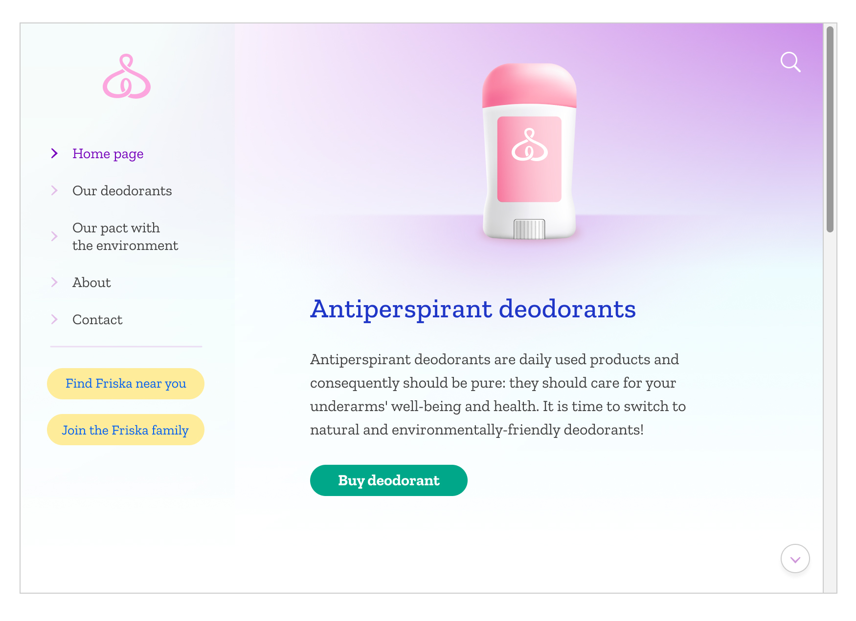

The website home page clearly states the value proposition and categorizes the site into sections, making it easy for the user to navigate the products and take action (online purchase with call-to-action buttons such as “Buy deodorant”). The page sections URLs represent the appropriate sections like [www.friskadeodorant.com/ourdeodorants](http://www.friskadeodorant.com), [www.friskadeodorant.com/antiperspirantdeodorant](http://www.friskadeodorant.com), [www.friskadeodorant.com/ourpactwiththeenvironment](http://www.friskadeodorant.com).

#### User flows

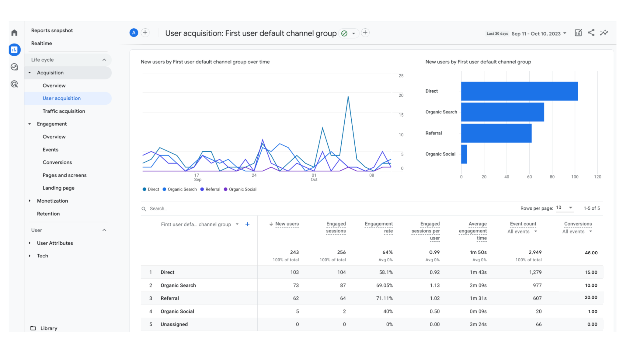

Over a month, Friska noticed that the website traffic fluctuated based on the marketing campaigns driving the audience from social media to the website. For the new product line launch, it will be important to replicate the same qualitative and targeted content to push the new product. Most users come from referral marketing; hence, it will be important to replicate these actions with the new product line.

#### Important pages

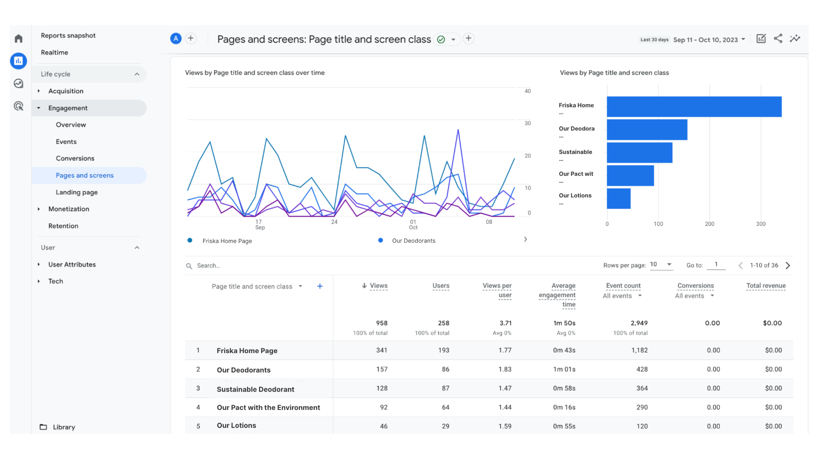

Top visited pages show that the sustainable deodorant is a popular product against other deodorants (that are not ranked in the top pages list). Therefore, it would be interesting for Friska to consider integrating the same sustainable product ingredients and packaging while designing and launching a new product line for active people. Adding a strong scent to the product line and communicating about the armpits’ freshness guarantee in the marketing messaging (website product page and campaigns) could be a solution.

#### Key conversion points



The website user experience leads to an 18.9% customer conversion rate with 46 purchases made online over the past month (46 conversions per 243 new users). This is a high conversion rate, and Friska should apply the same user experience (UX) and user interface (UI) techniques while launching the new product line and the efficient referral programs which represent 43.4% of total online conversions.

Throughout these steps, Friska is able to track the metrics that will measure the following objectives’ reach:

* **User traffic metric**: Increase website traffic by 20% in the next 6 months.
* **Conversion metric**: Boost online conversions by 10% in the next 3 months (such as purchases, subscriptions, and newsletter sign-ups).

Analyze Friska’s website audit findings. How is the website’s current tracking state? What areas would you recommend improving? Write your answers in the space below.

| ***Website audit insights*** |  |
| --- | --- |

### 

### Step 3: Determine what to track in Google Analytics 4

Google Analytics 4 provides you with a vast amount of tracking options to measure on your website. Focus on your objectives and only track the data that aligns with your specific goals and KPIs. Friska runs various marketing campaigns to promote the new deodorant line, including social media advertising, influencer partnerships, and email marketing. Friska tracks the effectiveness of each campaign and measures the traffic, conversions, and engagement generated by these initiatives.

Friska will track *the volume of deodorants purchased in one month from the traffic generated by the newsletter’s “call-to-action” button*.

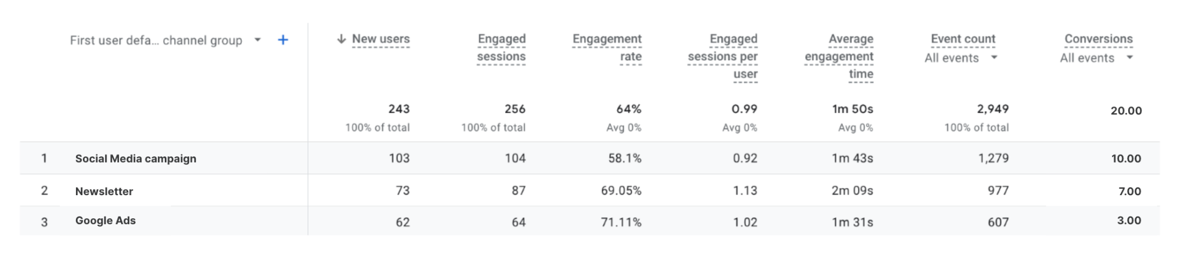

Think about what Friska is tracking in Google Analytics 4 and the KPIs. How does tracking this data allow you to measure and analyze the effectiveness of Friska’s online efforts? Write your answers in the space below.

| ***Tracking efforts*** |  |
| --- | --- |

### 

### Step 4: Set up Google Analytics 4 account

Set up a Google Analytics 4 account for your company’s website to begin tracking and measuring data!



### Step 5: Create a new property for the website

Once you’ve created a Google Analytics 4 account, you need to create a new property for the website you want to begin tracking. A property allows you to isolate and track data for a specific website. This is helpful when you need to track more than one website at the same time.

Friska sets up a new property on Google Analytics 4 to focus its data tracking on www.friskadeodorant.com.

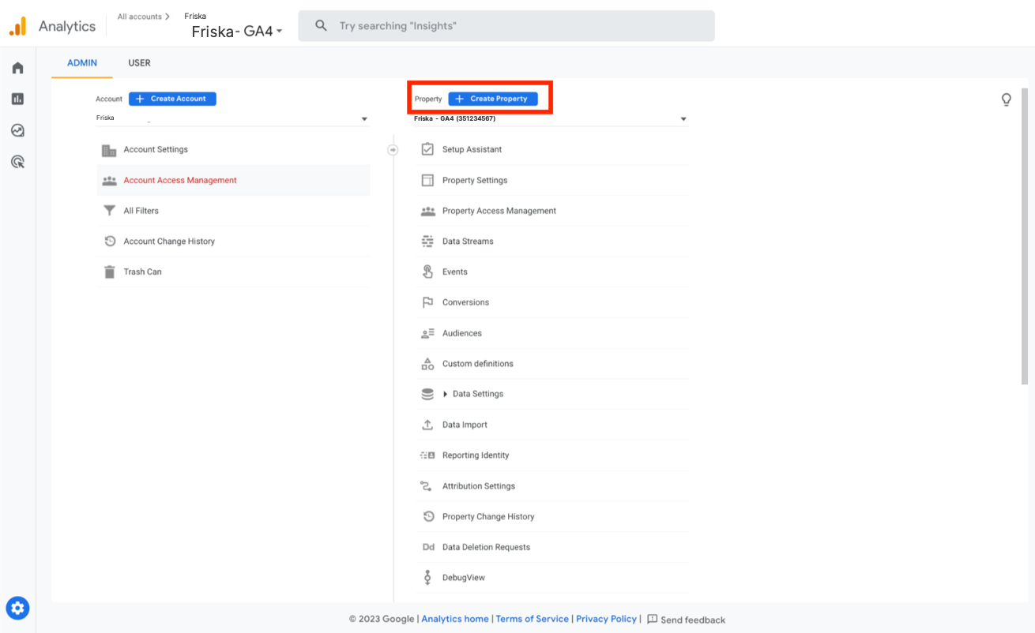

Think about what you know about the purpose of creating new properties for websites in Google Analytics 4. What are the benefits of creating properties? How can a property keep your website’s data organized and separated from other properties? Write your answer in the space below.

| ***Benefits of properties*** |  |
| --- | --- |

### Step 6: Install tracking code

A tracking code in Google Analytics 4 collects data on user interactions and website performance. This allows for a detailed analysis and reporting on user behavior and website effectiveness. Ensure that the tracking code is implemented and added on all relevant pages of the website. Verify the tracking code implementation to ensure it is functioning correctly by refreshing your Google Analytics 4 dashboard page over the next few days to start seeing some traffic data.

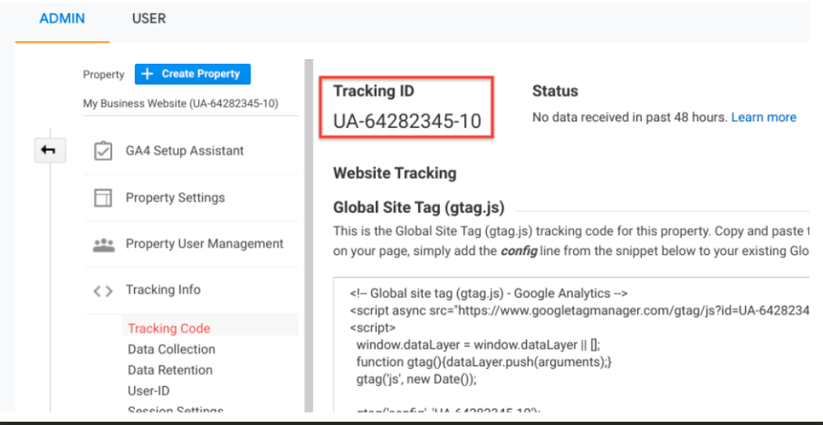

Why is it important to ensure that a tracking code is implemented to all relevant pages of a website? Write your answer in the space below.

| ***Tracking codes on website pages*** |  |
| --- | --- |

### 

### Step 7: Set up filters

Filters in Google Analytics 4 allow a user to control and refine the data that is collected and reported. This allows for accurate and relevant analytics.

To create a filter at the *view* level:

1. Sign in to Google Analytics 4.
2. Select **Admin**, and navigate to the view in which you want to create the filter.
3. In the VIEW column, select **Filters**.
4. Select **+ Add Filter**. (If this button is not visible, you do not have the necessary permission.)
5. Select **Create new Filter**.
6. Enter a name for the filter.
7. Select **Predefined** to select from the predefined filter types.
8. Select **Custom** to construct a custom filter from the options provided. If you create a custom filter, consult GA4’s definitions of the filter fields.
9. From the Available views list, select the views to which you want to apply the filter, then select **Add**.
10. Select **Save**.

Filters that Friska set up include:

* A filter to include only organic search traffic: To focus on organic search traffic, Friska created a filter to include only organic search sources. This helps to monitor SEO performance and understand how users find a website through search engines like Google.
* A filter to include or exclude specific URL parameters: Friska uses URL parameters for tracking and campaign-related purposes, and created a filter to exclude traffic with specific parameters. Friska excluded parameters used for tracking email campaign clicks to get a cleaner view of the website’s traffic.

Do the filters that Friska set up support what the company decided to track? Write your answer in the space below.

| ***Filters*** |  |
| --- | --- |

### Step 8: Configure advanced settings

Google Analytics 4 allows a user to configure advanced settings including:

* Enabling demographics
* Interests reporting
* Site search tracking
* Ecommerce tracking (if applicable)

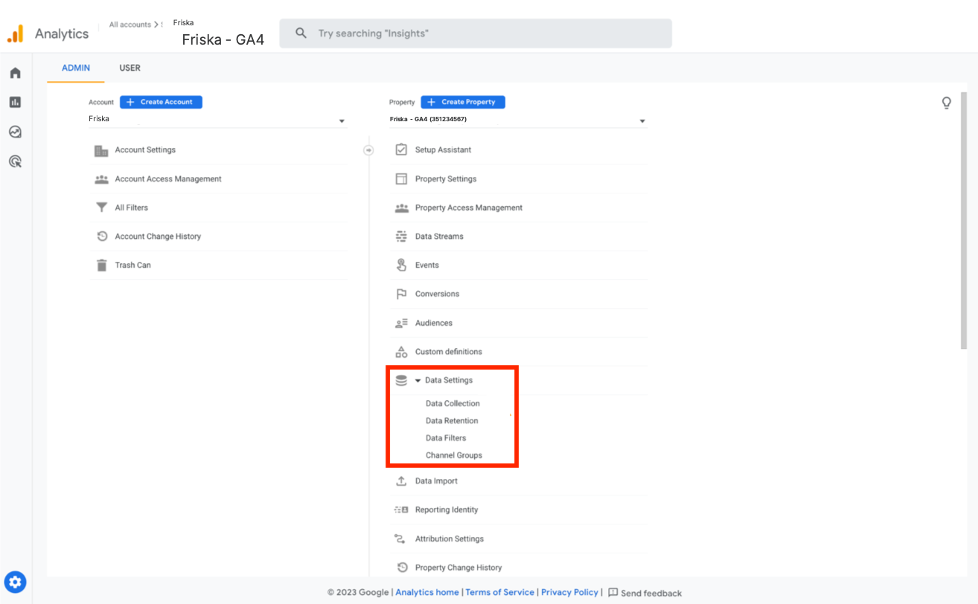

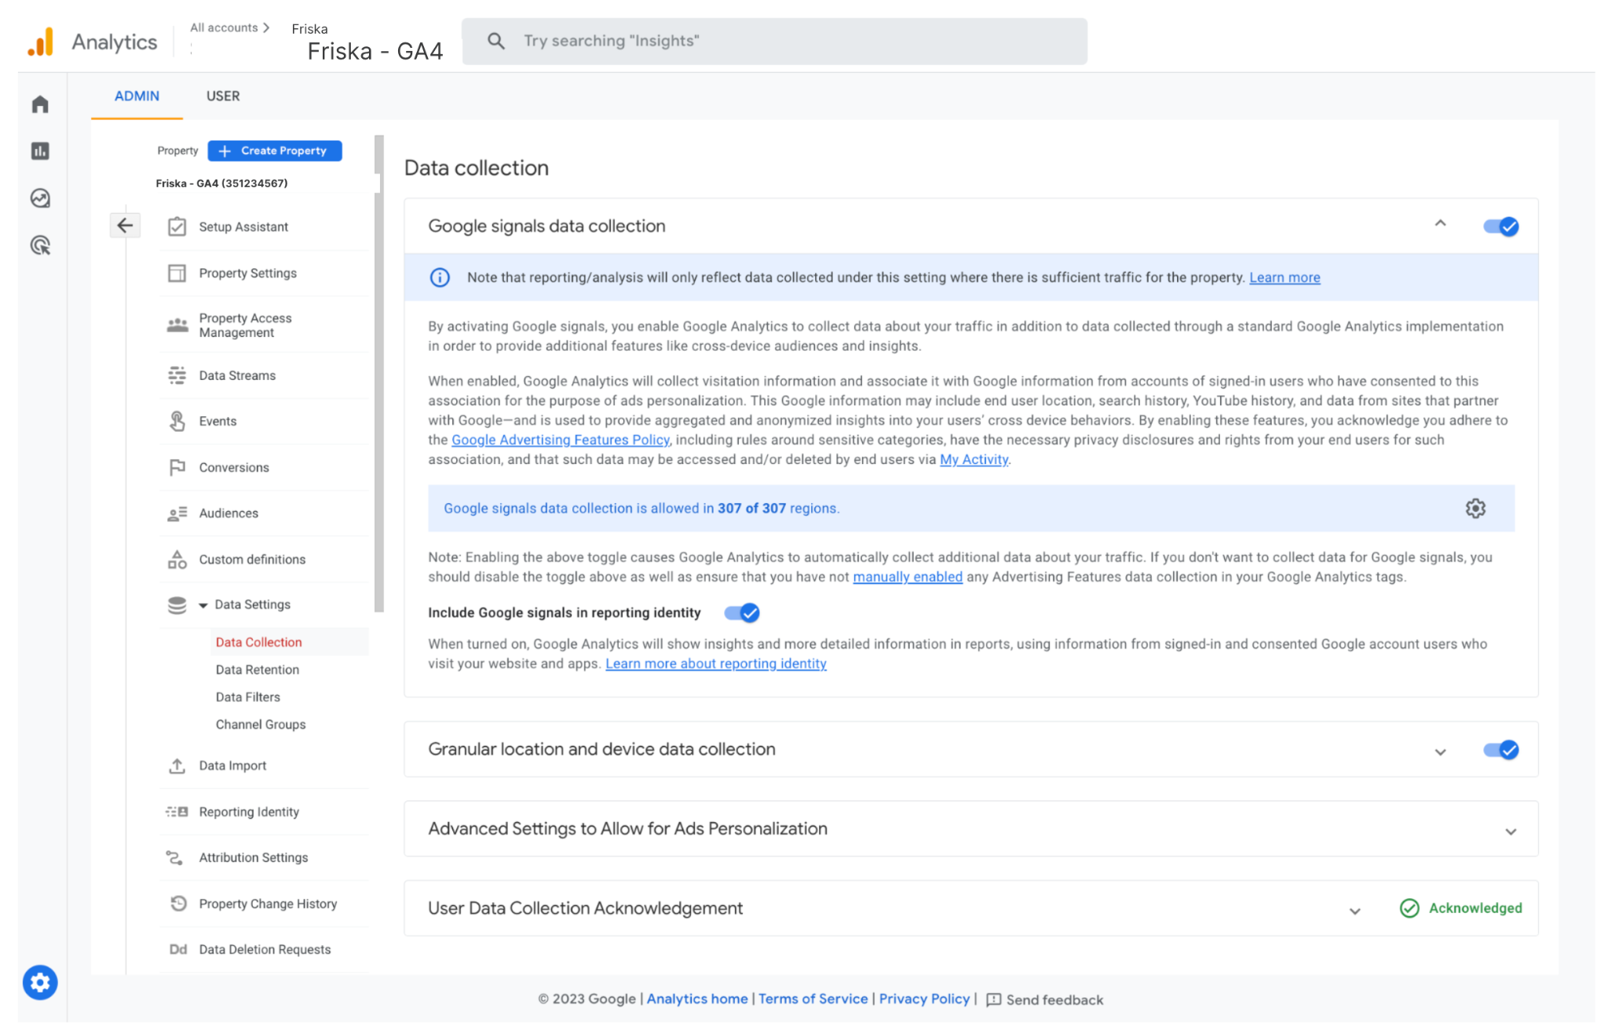

Configure advanced settings in a Google Analytics 4 property:

1. Sign in to Analytics.
2. Select **Admin**.
3. In the Property column, select **Data Settings** > **Data Collection**.
4. Under Advanced Settings to Allow for Ads Personalization, expand the panel.
5. Select the **settings gear** icon.
6. Turn off the switch for each geographical region you want to exclude, then select **Apply**.

How will the advanced settings that Friska configured support the company’s overall implementation goal? Write your answer in the space below.

| ***Advanced settings*** |  |
| --- | --- |

### Step 9: Create custom dimensions and metrics

Custom dimensions and metrics allow users to track additional data relevant to the website’s objectives and KPIs. This provides users with deeper insights into user interactions and behaviors.

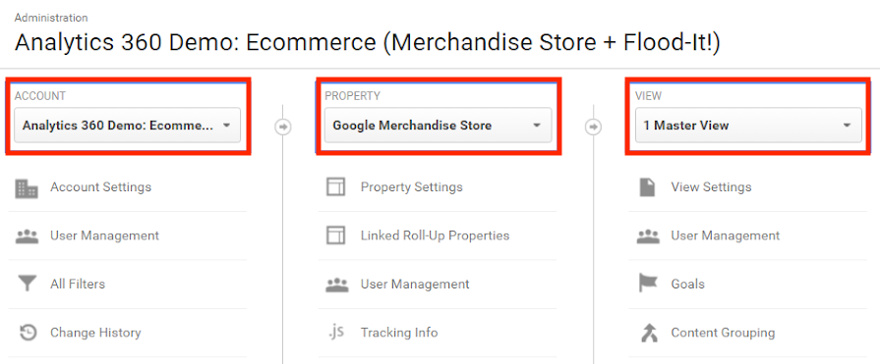

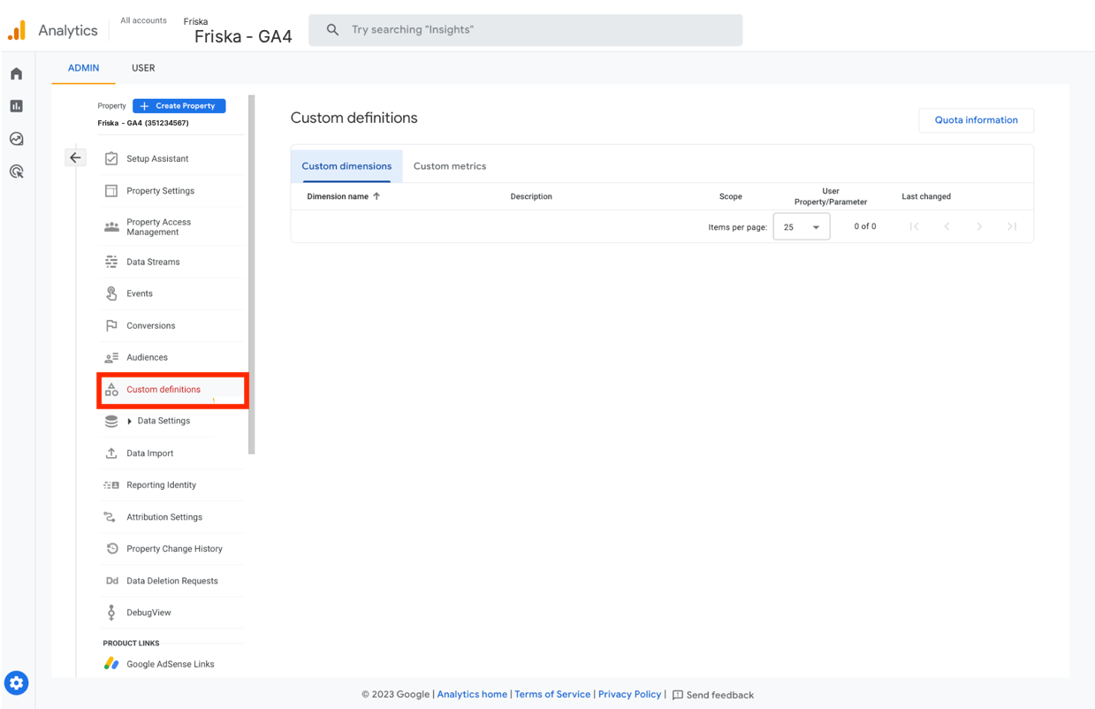

#### How to set up custom dimensions

1. Sign in to Google Analytics.
2. Select **Admin**, and navigate to the property to which you want to add custom dimensions.
3. In the PROPERTY column, select **Custom Definitions** > **Custom Dimensions**.
4. Select **New Custom Dimension**.
5. Add a Name. This can be any string, but use something unique so it’s not confused with any other dimension or metric in your reports.
6. Select the **Scope**. Choose to track at the Hit, Session, User, or Product level.
7. Select the Active box to start collecting data and view the dimension in your reports right away. To create the dimension but have it remain inactive, unselect the box.
8. Select C**reate**.

#### How to set up custom metrics

1. Sign in to Google Analytics.
2. Select **Admin**, and navigate to the property to which you want to add custom metrics.
3. In the PROPERTY column, select **Custom Definitions** > **Custom Metrics**.
4. Select **New Custom Metric**.
5. Add a Name. This can be any string, but use something unique so it’s not confused with another dimension or metric in your reports.
6. From the Formatting Type drop-down, select an Integer, Currency, or Time.
7. Select the Active box to start collecting data and see the metric in your reports right away. To create the metric but have it remain inactive, unselect the box.
8. Select **Create**.

Friska set the following dimensions and metrics in Google Analytics 4 and got the following results for the past month:

| **Dimension** | **30-Day Data** |
| --- | --- |
| * User type | * **New user**: 243 users * **Returning user**: 15 users (258 total users, 243 new users) |
| * Product category | * **Unscented**: 412 page views * **Fresh scent**: 200 page views * **Floral scent**: 180 page views * **Citrus scent**: 166 page views |
| * New users marketing channel | **Direct**: 103 new users  **Organic search**: 73 new users  **Referral**: 62 new users  **Organic social**: 5 new users |

| **Metric** | **30-Day Data** |
| --- | --- |
| * Conversion rate by product | **Unscented**: 8.2%  **Fresh scent**: 7.5%  **Floral scent**: 6.9%  **Citrus scent**: 5.4% |
| * Average time spent on product page (in seconds) | **Unscented**: 38 seconds  **Fresh scent**: 42 seconds  **Floral scent**: 34 seconds  **Citrus scent**: 45 seconds |
| * Checkout abandonment rate | **Cart abandonment**: 28%  **Shipping details abandonment**: 14%  **Payment abandonment**: 6% |

Analyze the custom dimensions and metrics for Friska. What insights are highlighted about user interactions and behaviors? Write your answer in the space below.

| ***Custom dimensions and metrics*** |  |
| --- | --- |

### 

### Step 10: Configure subgoals

Defining and configuring subgoals is a strategy used to track and measure specific actions or events on a website that contribute to the overall success of your primary or main goal. Subgoals are used to provide a more granular view of user interactions and can help you gain insights into the steps users take before completing the primary goal. The aim of defining and configuring subgoals is to:

* **Measure micro-conversions**: Subgoals allow you to track smaller, intermediate actions that lead users toward the main conversion or goal. These can be actions like signing up for a newsletter, adding items to a shopping cart, or downloading a resource. By tracking subgoals, you can see which steps in the user journey are effective in driving conversions.
* **Analyze user behavior**: Subgoals help you understand how users navigate your website and where they drop off or abandon the conversion process. This insight can be used to optimize the user experience and identify bottlenecks in the conversion funnel.
* **Optimize marketing campaigns**: Tracking subgoals can also help you assess the performance of different marketing channels and campaigns. You can see which sources or channels are driving users to complete subgoals and, by extension, the main goal. This information can guide your marketing efforts and budget allocation.
* **Set up funnel visualization:** Google Analytics 4 allows you to create a conversion funnel by defining a sequence of subgoals leading to the main goal. This helps you visualize the conversion path and identify areas that may need improvement.
* **Make data-driven decisions**: Subgoal tracking provides you with data that can be used to make data-driven decisions to improve your website's performance, user experience, and overall conversion rate.

Subgoals can include:

* Destination goals
* Event goals
* Duration goals

Below are the subgoals for Friska:

#### **Destination goal**: Product page visit

* + **Destination URL**: The URL of the product page where users can view and learn more about the sustainable deodorant products.
  + **Purpose**: Track the number of visitors who are interested in the products and reach the product page.

#### **Event goal**: Add to cart event

* + **Category/Action/Label**: Set up an event to track when users add a product to their shopping cart.
  + **Purpose**: Measure the level of interest in the products and track users who are actively considering a purchase.

#### **Duration goal**: Product exploration duration

* + **Duration**: Set the goal for users to spend a minimum of, for example, 2 minutes on the product pages.
  + **Purpose**: Ensure that users are engaging with the product information and content, which may indicate a higher level of interest.

Are Friska’s subgoals set up in a way to assess the effectiveness of Friska’s marketing strategies? Why or why not? Write your answer in the space below.

| ***Subgoals*** |  |
| --- | --- |

### 

### Step 11: Implement event tracking

Event tracking allows a user to capture specific user interactions or actions on the website. These can include product details page clicks, company mission statement page clicks, or cart adding volume.

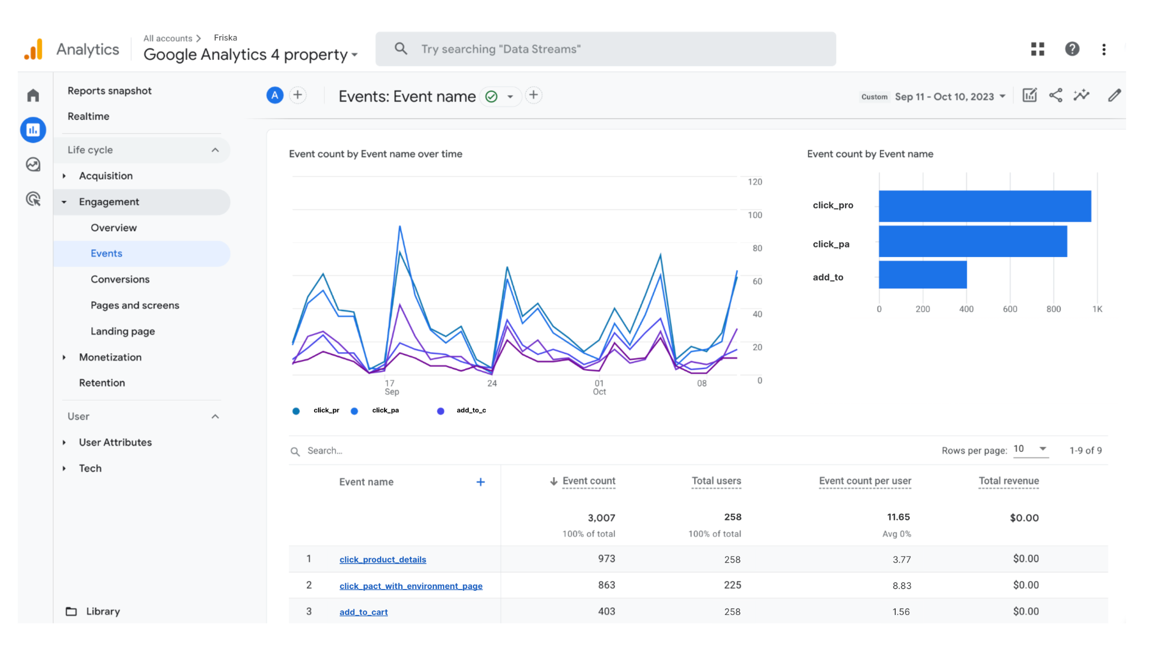

What does Friska’s event tracking data tell you about their website’s product details page clicks, company mission statement page clicks, and cart adding volume? Why do you think this is? Write your answer in the space below.

| ***Event tracking*** |  |
| --- | --- |

### Step 12: Set up segmentation conversion funnels

Create segments to analyze different user groups or behavior patterns. Examples of segments include:

* Mobile users
* Desktop users
* Countries
* Paid campaigns

Creating segments in Google Analytics 4 can provide valuable insights into user behavior and conversion patterns for a company like Friska. To analyze different user groups and their conversion paths, you can define segments for mobile users, desktop users, countries, and users from paid campaigns. Below are segments with associated data and insights for each.

In addition to these segments, it's essential to create conversion funnels within Google Analytics 4 to track user behavior through different stages of the customer journey. For example, you can set up goals or events to track actions like adding products to the cart, initiating checkout, and completing a purchase. Analyzing these funnels for each segment will help you identify where users drop off or convert, providing insights on optimizing the user experience and marketing strategies.

| **Segment** | **Insights** |
| --- | --- |
| **Mobile users**: This segment includes users who access Friska’s website via mobile devices.   * Total users: 100 * Conversion rate: 8% | * Mobile users account for a significant portion of website traffic. * The conversion rate for mobile users is 8%, indicating that the mobile experience and product presentation may be effective. |
| **Desktop users:** This segment includes users who access Friska’s website via desktop computers.   * Total users: 120 * Conversion rate: 10% | * Desktop users are a slightly smaller segment compared to mobile users but have a higher conversion rate of 10%. This might suggest that desktop users are more engaged or find the website more user-friendly. |
| **Countries**: This segment groups users by their countries of origin.   * United States: 80 users * Canada: 50 users * United Kingdom: 30 users * Other countries: 98 users * Total users: 258 | * The United States has the most users, followed by Canada and the United Kingdom. * The conversion rate can be calculated for each country individually to identify which market is the most responsive to Friska's products. |
| **Paid campaigns**: This segment includes users who arrive at the website through various paid marketing campaigns (e.g., Google Ads, social media ads, influencer partnerships).   * Google Ads: 40 users * Facebook Ads: 35 users * Instagram influencer: 15 users * Total users: 90 | * Paid campaigns generate a significant portion of traffic, with Google Ads being the most successful in terms of user acquisition. * The conversion rate can be calculated for each paid channel to determine which campaign is delivering the highest ROI. |

What insights did you discover about Friska’s segmentation conversion funnel? Why do you think this is? Write your answer in the space below.

| ***Segmentation conversion funnels*** |  |
| --- | --- |

### Step 13: Define and configure conversion funnel

Define and configure the steps of the conversion funnel based on the website’s structure and key conversion points. This helps track a user’s journey, identifies where users drop off, and optimizes the conversion process for improved performance.



To set up conversion funnels in Google Analytics 4 for Friska, you should define and configure the steps of the funnel based on the website's structure and key conversion points. This will allow you to track the user's journey, identify where users drop off, and optimize the conversion process.

Based on Friska’s website's structure, you will define and configure the steps of the conversion funnel knowing the five sections in the website menu are Home page, Our deodorants, Our pact with the environment, About, and Contact.

#### Define key conversion points

* **View Product Listings**: This is where users browse the deodorant products.
* **Add to Cart**: The action of adding a product to the cart is a critical step in the conversion process.
* **Initiate Checkout**: Users reach the checkout page.
* **Complete Purchase**: Users reach the order confirmation page after making a purchase.

#### Configure the funnel steps

##### Goal 1: View Product Listings:

* + **Name**: View Product Listings
  + **Type**: Destination (if there is a specific URL for product listings)

This goal captures users who visit the product listings page.

##### Goal 2: Add to Cart:

* + **Name:** Add to Cart
  + **Type**: Event (Track the button click event for adding to the cart.)

To configure this goal, you'll need to set up event tracking for the "Add to Cart" button on the product pages.

##### Goal 3: Initiate Checkout:

* + **Name**: Initiate Checkout
  + **Type**: Destination (if there is a dedicated checkout URL)

This goal tracks users who reach the checkout page.

##### Goal 4: Complete Purchase:

* + **Name**: Complete Purchase
  + **Type**: Destination (the URL of the order confirmation page)

This goal is triggered when users reach the order confirmation page after making a purchase.

#### Set up funnel steps

##### Goal 1: View Product Listings:

No funnel steps are needed for this goal since it's the first step in the conversion process.

##### Goal 2: Add to Cart:

No funnel steps are needed for this goal. Users should go directly from viewing products to adding them to the cart.

##### Goal 3: Initiate Checkout:

Add a funnel step for "View Product Listings" to track users who move from the product listings to the checkout page.

* **Funnel step**: View Product Listings
  + **Label**: View Product Listings
  + **Destination**: URL of the product listings page

##### Goal 4: Complete Purchase:

Add two funnel steps to track users who move from the checkout page to the order confirmation page.

* **Funnel step**: Initiate Checkout to Complete Purchase
  + **Label**: Initiate Checkout to Complete Purchase
  + **Destination**: URL of the order confirmation page

What insights did you discover about a user’s journey on Friska’s website? Why do you think this is? Write your answer in the space below.

| ***User’s journey*** |  |
| --- | --- |

### Step 14: Create custom dashboards and reports

Set up and analyze reports related to the website’s performance, user behavior, conversion rates, and goal achievements.

You have analyzed several of Friska’s reports in this exercise. What findings from Friska’s reports surprised you and why? Write your answer in the space below.

| ***Report findings*** |  |
| --- | --- |

### Step 15: Compile findings for the implementation plan

Compile all the configurations, settings, and insights into a comprehensive implementation plan presentation. Typically this is in a PowerPoint or Google Slides presentation and includes the following:

* Executive summary
* Implementation steps
* Tracking code snippets
* Goals
* Funnels configuration

### Step 16: Share with stakeholders

Once your Google Analytics 4 implementation plan is organized and all steps have been completed, present your findings to stakeholders for their approval and validation. This ensures buy-in, alignment with business goals, an opportunity to hear feedback, and a chance to gain support for your data tracking and analysis strategy.

Friska’s final Google Analytics 4 implementation plan includes details on website performance, campaign effectiveness, user behavior, and conversion rates. The plan highlights the metrics, dimensions, and segments that are tracked and analyzed to gain meaningful insights.

### Create a presentation!

Compile all of your findings, insights, reports, and recommendations for Friska’s website into a summarized presentation format. Use either Google Slides or Microsoft PowerPoint and make it your own! Customize each slide as if you were going to present it to stakeholders (with a title for each slide). You can add speaking points to the notes section and even practice giving the presentation to stakeholders by speaking out loud. This will help prepare you for when the time comes to present your findings on a real product’s website.

When you’re ready, go back to [the assignment](https://www.coursera.org/learn/measurement-and-analysis/assignment-submission/VLE3u/google-analytics-implementation-plan) to complete the reflective questions.